LAPTOP REQUEST CATALOG ITEM SERVICENOW

Team Id: NM2025TMD13363

Team Leader: R. TAMILARASU

Team Member 1: S. SELVARAJ

Team Member 2 : T. YUGABHARATHI

Team Member 3 : S.SARAVANAN

# Abstract

This project focuses on designing and implementing a laptop request Management System using the Service Now platform. The system enables recording, tracking, and analysing family expenditures in a structured and automated way. Key features include creating custom tables, defining columns, configuring forms, applying business rules for automation, and establishing relationships between daily and overall expenses.

# Introduction

Managing household expenses is often challenging without a proper tracking system. Service Now provides a platform to create customized applications that can automate this process. By building a dedicated Family Expenses application, we can:

● Record daily expenditures

● Ensure mandatory expense details are filled  Automate data handling with business rules

● Maintain relationships between daily expenses and total family expenses

This project demonstrates how to leverage Service Now’s low-code platform to solve a real-life problem with minimal effort.

## **UPDATE SET**

## 1Step:open service now. click on all >> search for update sets select local update sets under system update sets click on new fill the following details to create a update set as: “laptop request” click on submit and make current by clicking on the button it activates the update set .

## **Create Service CatLog Item**

## open service now. click on all >> service catalos select maintain items under catalos definitions click on new.

## fill the following details to create a new catalos item name: laptop request catalos: service catalos

## category : hardware

## short description: use this item to request a new laptop click on ‘save’

## **Create Catalog Up policies**

## click on all>> search for service catalos select maintain item under catalos definition search for ‘laptop request’ which is created before select ‘laptop request’ and scroll down click on “catalos up policies” in the catalog up policies related list tab click on new give short description as: show accessories details set the catalog condition in the related list tab ‘when to apply’

## **Exporting changes to another instances**

## click on all >> search for update sets select local update set select created update set i.e. ‘laptop request project’ set the state to ‘complete’ in the related list update tab, updates are visible which we perform under this update set. click on export to xml ,it download one file

## **RETRIEVING THE UPDATE SET**

## open another instance in incognito window login with credentials click on all>> search for update sets select “retrieved update set” under system update set it open retrieved update set list and scroll down click on import update set from xml

## upload the downloaded file in xml file click on upload and it gets uploaded.

**TEST CATALOG ITEM**

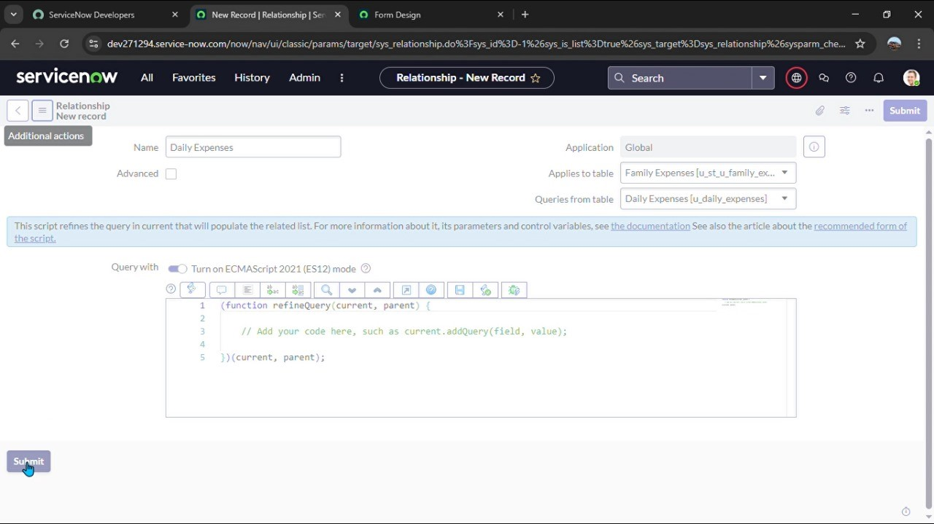

* Upload the downloaded file in XML file  
  Click on Upload and it gets uploaded. Search for service catalog in application navigator in target instance  
  Select catalog under service catalog   
  Select hardware category and search for ‘laptop request’ item  
  Select laptop request item and open it   
  It shows three variables only

## Results

## the laptop request catalog item project successfully streamlines the process of requesting laptops within the organization by leveraging service now’s service catalog capabilities. through the implementation of a dynamic catalog item, the project ensures that users have an intuitive and user-friendly interface, reducing errors and improving efficiency. This project demonstrates how service now can be used to replace manual, error-prone processes with automated, efficient, and user-centric solutions. it not only improves service delivery but also enhances employee satisfaction by providing a modern and streamlined request experience.

## Applications

● Personal household expense tracking

● Budget planning for families

Can be extended for small businesses or clubs/associations to track group expenses

# Conclusion

The Family Expense Management System developed in ServiceNow provides a structured and automated way of managing household finances. By leveraging ServiceNow features such as update sets, tables, forms, business rules, and relationships, the project ensures accurate expense recording, efficient data entry, and improved financial tracking.

This project demonstrates how a simple real-world problem can be solved using the capabilities of a cloudbased low-code platform.